

Faculty of Engineering (Diploma)
Semester –5TH CE

Subject Name- COMPUTER ORGANIZATION AND ARCHITECTURE
Subject Code:- DE103504
Faculty Name –Khushbu Goswami

Unit :V

Input-Output Organization

Explain I/O interface
    - It consists of two data registers called ports, a control register, a status register, bus buffers, and timing and control circuit.
    - The interface communicates with the CPU through the data bus.
    - The chip select and register select inputs determine the address assigned to the interface.
    - The I/O read and writes are two control lines that specify an input or output,respectively.
    - The four registers communicate directly with the I/O device attached to the interface.
    - A command is passed to the I/O device by sending a word to the appropriate interface register.
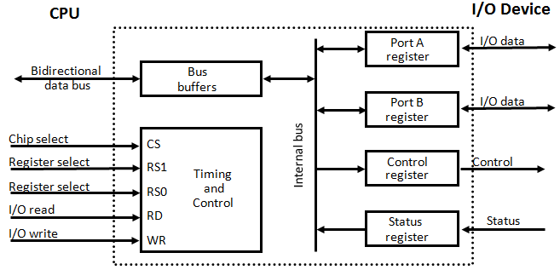
    - The control register receives control information from the CPU.

C  S | RS  1 | RS  0 | Register Selected
0 | X | X | None: data bus in high  impedance
1 | 0 | 0 | Port A register
1 | 0 | 1 | Port B register
1 | 1 | 0 | Control register
1 | 1 | 1 | Status register

    - For example, port A may be defined as an input port and port B as an output port.
    - The interface registers communicate with the CPU through the bidirectional data bus.
    - The address bus selects the interface unit through the chip select and the two registerselect inputs.
    - The two register select inputs RS1 and RS0 are usually connected to the two leastsignificant lines of the address bus.
    - These two inputs select one of the four registers in the interface as specified in the table accompanying the diagram.
    - The content of the selected register is transfer into the CPU via the data bus when the I/O read signal is

enables.
    - The CPU transfers binary information into the selected register via the data bus when the I/O write input is enabled.

Differentiate various Modes of Data Transfer with I/O
    - Data transfer to and from peripherals may be handled in one of three possible modes.
      - Programmed I/O
      - Interrupt initiated I/O
      - Direct Memory Access(DMA)

Programmed I/O
    - The I/O device does not have direct access to memory.
    - A transfer from I/O device to memory require the execution of several instruction by CPU(device to CPU and CPU to memory, no of words transferred)
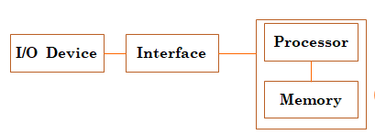
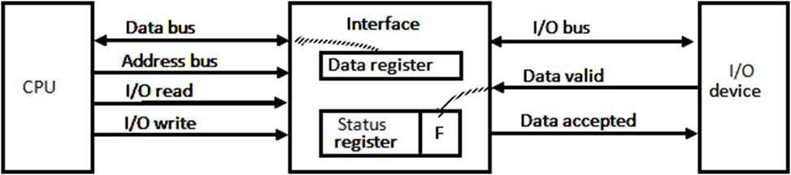
    - When a byte of data is available, the device places it in the I/O bus and enables its data valid line.
    - The interface accepts the byte into its data register and enables the data accepted line.
    - The interface sets a bit in the status register that we will refer to as an F or "flag" bit.
    - The device can now disables the data valid line.
    - Then reading the status register into a CPU register and check the value of the flag bit .
    - If the flag is equal to 1, the CPU reads the data from the data register.
    - The flag bit is then cleared to 0 by CPU or Interface(depends o IC)
    - Then Interface disable the data accepted line and the device can transfer the next data byte.

Interrupt Initiated I/O.

    - In programmed initiated, CPU stays in a program loop until the I/O unit indicates that it is ready for data transfer.
    - It keeps the processor busy without need.
    - It can be avoided by using an interrupt facility .
    - When the data are available from devices, interface issues an interrupt request signal.
    - In the meantime CPU can proceed to execute another program.
    - The interface meanwhile keeps monitoring the device.
    - When the interface determines that the device is ready for data transfer, it generates an interrupt request to the computer.
    - Upon detecting the external interrupt signal, CPU stops the task, branches to the service program to process I/O and then return to the task it was originally performing.

DMA(Direct Memory Access)
    - The transfer of data between a fast storage device such as magnetic disk and memory is often limited by the speed of the CPU.
    - Removing the CPU from the path and peripheral device manage the buses directly will improve the speed of transfer.
    - This transfer technique is called DMA.
    - A DMA controller takes over the buses to manage the transfer directly between the I/O devices and memory.
    - BR is used by DMA Controller to request CPU to relieve control of buses.
    - BR is active, then CPU place address bus, data bus, read and write line into high impedance state.
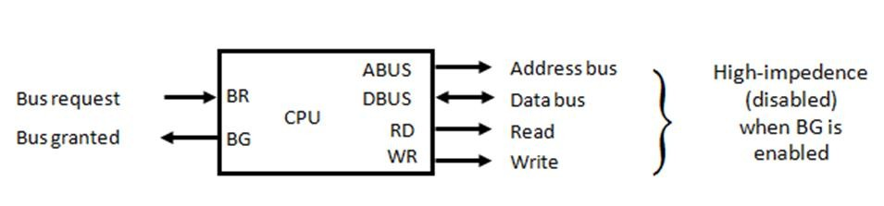
- The CPU activate the BG to inform DMA that buses are in high impedance state.
- DMA takes the control of buses and conduct memory transfer.
- When the DMA terminates the transfer, it disable the bus request line(BR).
- CPU disable the BG.

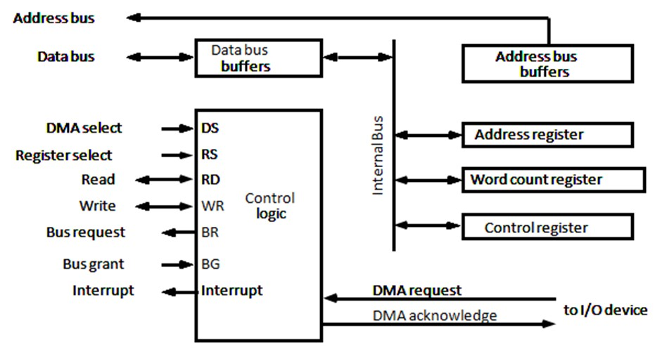
    - The register in the DMA are selected by the DS (DMA select) and RS (register select) inputs.
    - The RD (read) and WR (write) inputs are bidirectional.
    - When the BG is 0, the CPU can communicate with the DMA registers through the data bus to read from or write to the DMA registers.
    - When BG= 1, the CPU relieve the buses and the DMA can communicate directly with the memory
    - The word count register holds the number of words to be transferred.

Describe Input-Output Processor (IOP)
    - Instead of having each Interface communicate with CPU, computer may have one or more external processor.
    - Each processor communicates directly with I/O devices.
    - IOP may be classified as a processor with direct memory access capability that communicates with I/O devices.
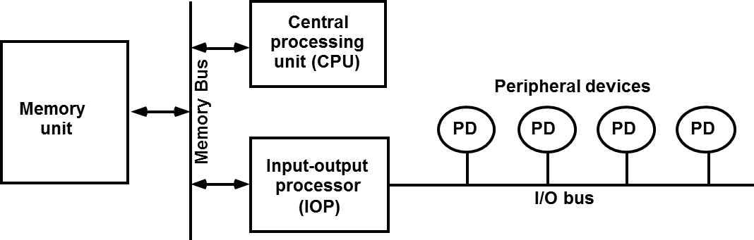
    - IOP provides a path for transfer of data between various peripheral devices and the memory unit.
    - IOP operates independent of the CPU.

Describe CPU-IOP communication

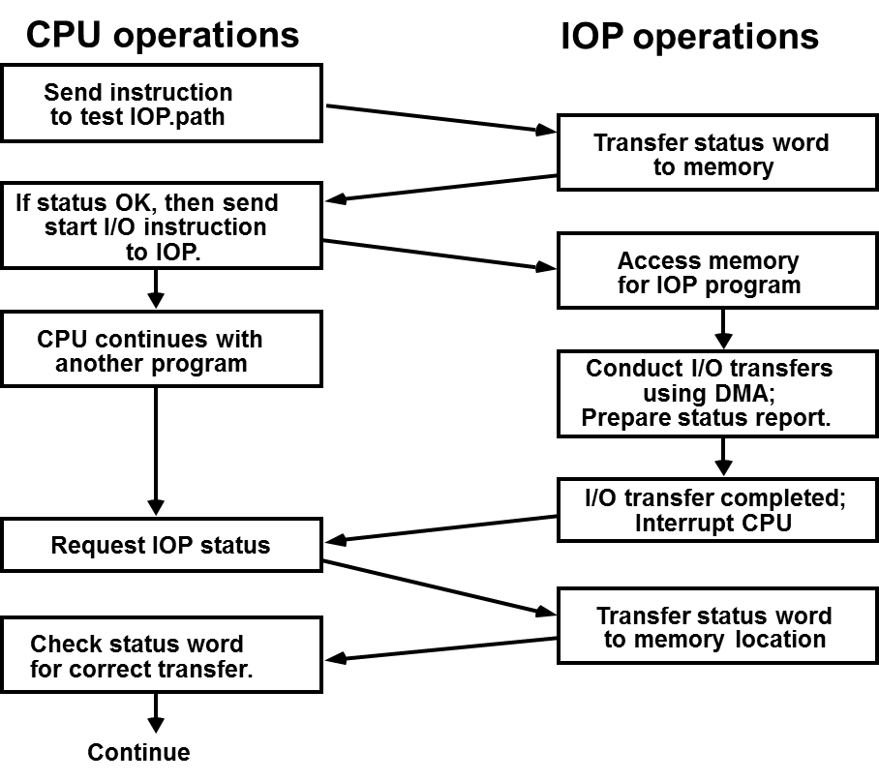

    - CPU send an instruction to test the IOP path.
    - The IOP responds by inserting a status word in memory for CPU.
    - Status word indicate the condition of the IOP and I/O device(IOP overload condition, device busy, device ready)
    - The CPU check the status word in memory to decide what to do.
    - If status is OK, send start I/O instruction to IOP.
    - Now CPU is continue with another program while IOP is busy with I/O program.
    - When IOP terminates the execution, it send interrupt request to CPU.
    - CPU send request for IOP Status.IOP send status report. It indicates the transfer has been completed or if any error occurs during the transfer.CPU check status word for correct transfer.

